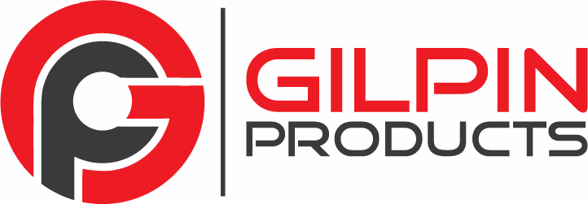

Gilpin Products, LLC warranty of ALUMINUM AND STEEL PRODUCTS is as described herein.

In normal use, we warrant our products against defects in Gilpin Products’ supplied materials and workmanship, normal wear and tear excepted, for as long as you own them. Compliance with building codes is the responsibility of the installer and/or purchaser. Installations in violation of building codes void this or any warranty. We do not warrant against problems caused by the installer and/or purchaser.

Aluminum Products Warranty
In normal use, Gilpin Products, LLC warrants the product and finish against rust, peeling, cracking, or blistering caused by defects in Gilpin supplied materials or workmanship for as long as you own this product, according to following schedule:

Since Date of Purchase | Warranty
1 – 5 years | 100%
5 – 10 years | 75%
10 – 15 years | 50%
Greater than 15 years | 25%

Steel Products Warranty
While Gilpin Products does warrant against material and workmanship; normal wear and tear excepted, we do not warrant against rust or corrosion or defects in the coating. It is the responsibility of the installer and owner to paint all scratches, abrasions, nicks or other defects after installation and to maintain the finish during the lifetime of the product. Otherwise the following schedule applies:

Since Date of Purchase | Warranty
1 year | 100%
2 – 5 years | 50%
Greater than 5 years | No Warranty

The Following Applies to All Products:
- Damage resulting from impact, abrasion, improper installation, abuse, alteration, negligence or act of God is not warranted by Gilpin Products, LLC.
- This warranty covers only the product itself. Consequential damages are expressly excluded.
- This warranty is issued to the original purchaser and is non-transferable. Proof of purchase in the form of an original receipt validating materials are products from Gilpin Products, LLC is required.
- Removal and reinstallation cost of materials is the responsibility of the purchaser. If more than one item was purchased, claims will be considered only for individual defective items, not for complete set purchased.

We reserve the right to require material to be returned at purchaser’s cost to our plant for our inspection. Our determination of validity of any claim is final. If claim is valid, Gilpin Products, LLC will repair or replace defective product or refund at our sole discretion.

Except as specifically provided herein, Gilpin Products, LLC. makes no other warranties express or implied.

